Create a folder GitHub Project

Open cmd

Command: git init

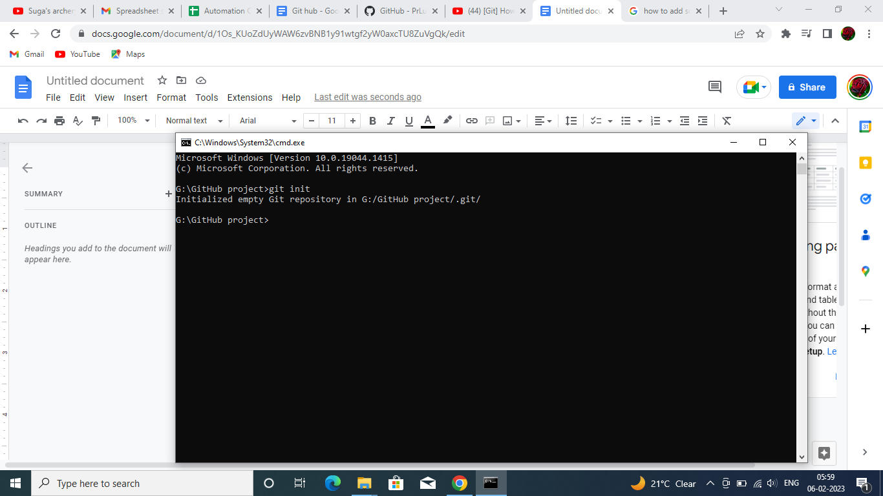

2. Check git status

Command : git status

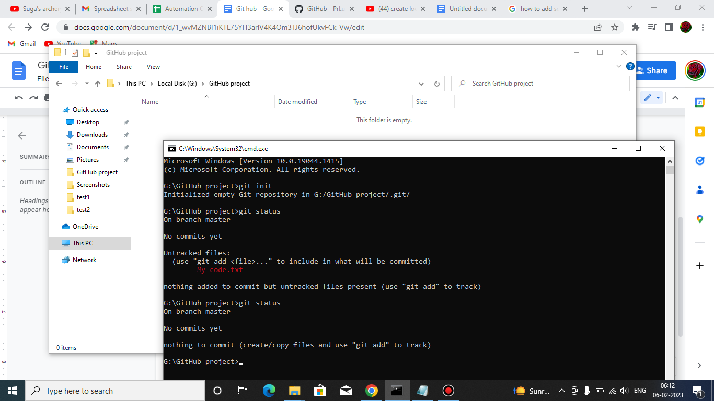

Created a document name “Mycode” and wrote message in it as “Hi Github new Homework by me”

Command : git remote add cloudrepo https://github.com/PrLu/Automation-Corner.git

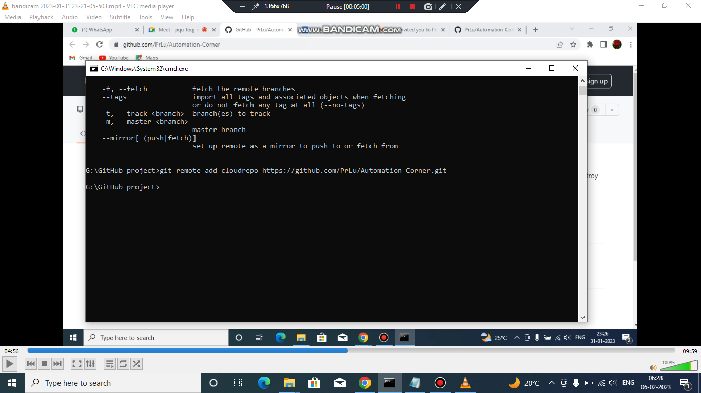

Command: git pull cloudrepo master

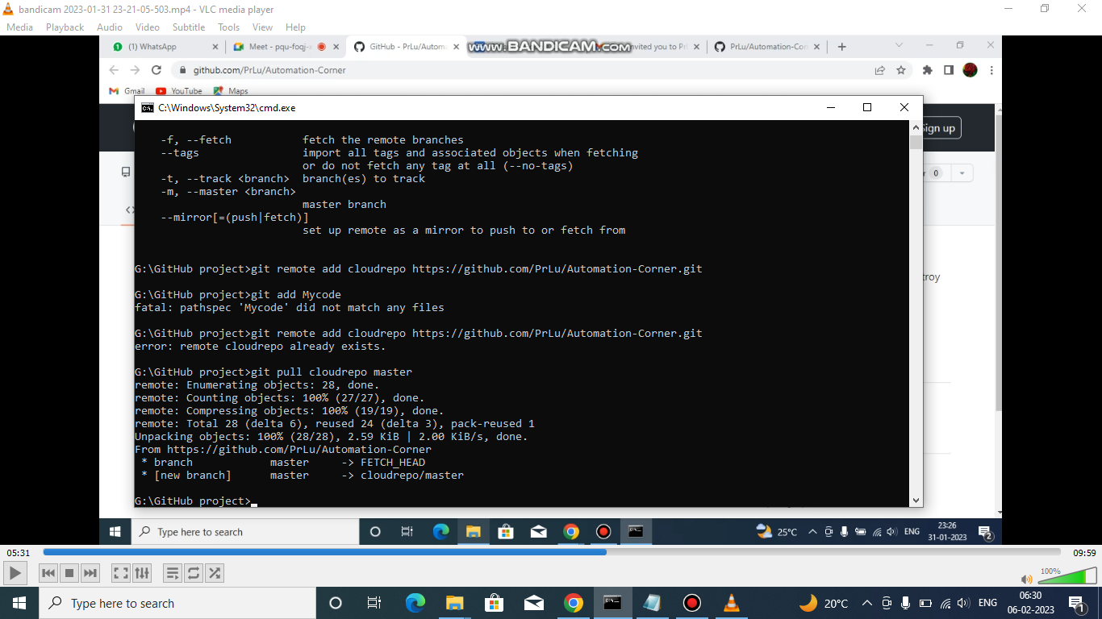

Add file name Mycode

Command:git add .

Dgfghd

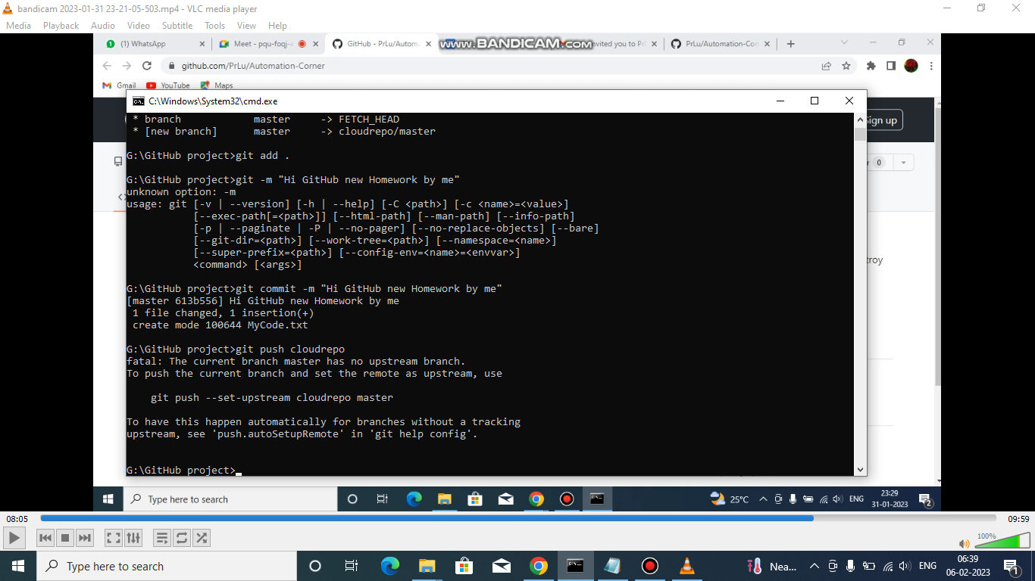git commit -m”Hi GitHub new Homework by me”

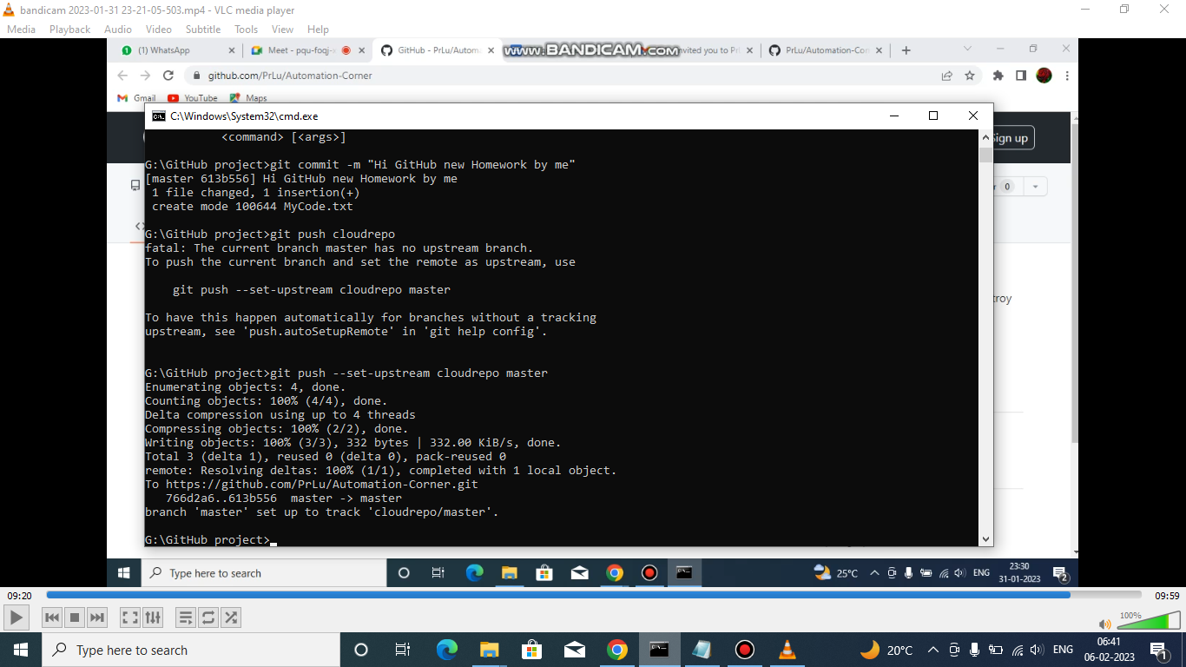git push –set-upstream cloudrepo master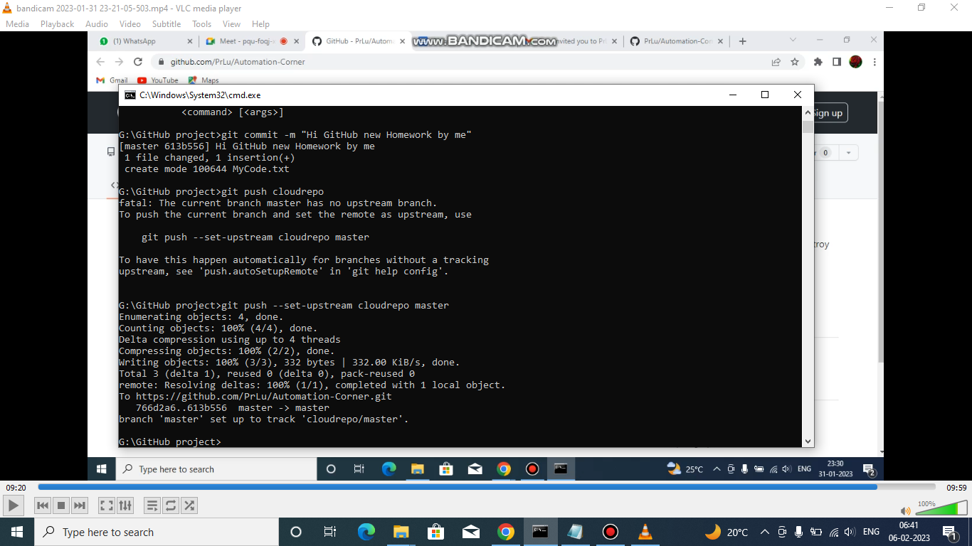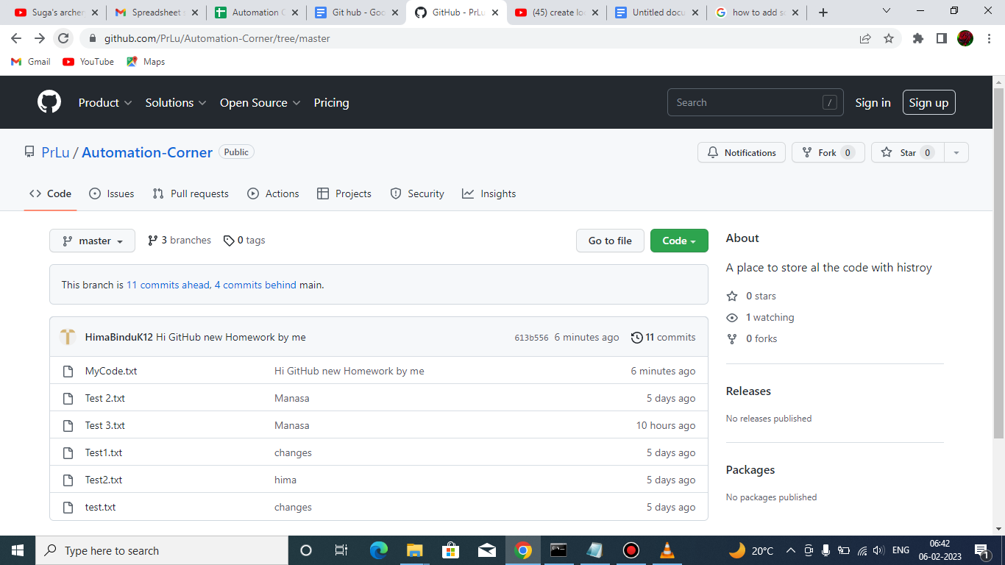make changes in the file and add

Git add .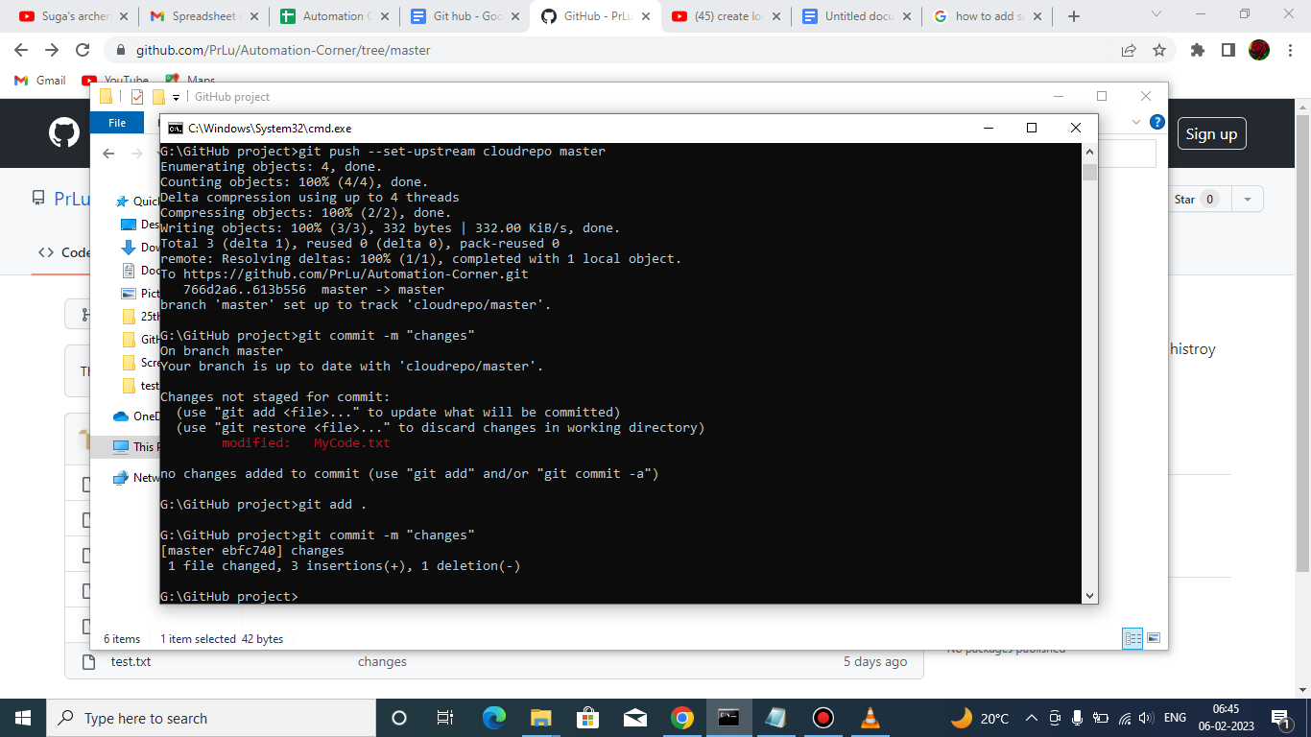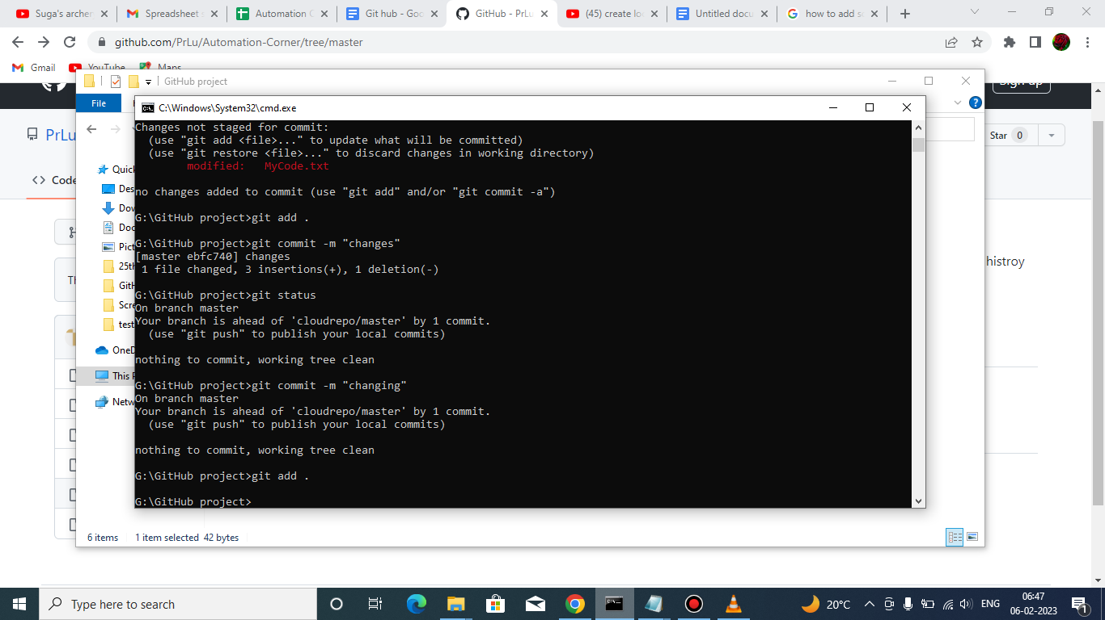commit changes

Git commit -m “changing” and now push command:git push --set-upstream cloudrepo master